George K. Staropoli
5419 E. Piping Rock Road, Scottsdale, AZ 85254-2952
602-228-2891 / 602-996-3007 (f)
george@pvtgov.org http://pvtgov.org

February 23, 2009

Hon. Paul J. McMurdie
Maricopa Superior Court
101 W. Jefferson # 413
Phoenix, AZ 85003-2243

Re: LC2008-000740
special action from OAH 08F-H089004-BFS
new facts

Dear Judge McMurdie:

If I had been permitted to intervene, these facts, discovered subsequent to filing the Motion to Intervene, would have been presented appropriately. Rule 60(c)(6) "does not limit the power of a court to entertain an independent action to relieve a party from judgment, order . . . or to set aside a judgment for fraud upon the court."

In short:

- Petitioner and real party in interest, Ron Merrit, had quitclaimed his deed to his co-owned property in the Phoenix Townhouse subdivision on October 10, 2008, prior to the superior court special appeal of October 23. (Exhibit 1). I believe this issue became moot at that point.
- The new co-owner is the legal person of Big Henge Enterprises, LLC whose two members are Merrit and Hernandez. Big Henge is not a successor in interest to the Merrit Petition.
- John Hernandez, the other real party in interest, and co-owner of the Phoenix Townhouse with along with Merrit, did not file a Petition, but was falsely named as a defendant in the special action. Hernandez is listed on the Petition as a homeowner, but did not sign it! (Exhibit 2). It appears that there are no valid real parties in interest in the special action.
- There is no legal entity named "Phoenix Townhouse Association", the stated Plaintiff. The name appears on the court/OAH filings and in correspondence attached as exhibits to the supplemental Petition filed by Merrit on September 22. There are no records or names of any directors of the board or president on any of these documents. The "Association" named in the Phoenix Townhouse declaration is "Phoenix Townhouse Corp." (Exhibit 3) whose president is Richard Flood with Maggie O'Dell as a director (as shown on the ACC annual reports). There is no trade name filed as such.
- The 2004 notice filing required under ARS 33-1807(J) also falsely names "Phoenix Townhouse Association" as the legal name of the subdivision (Exhibit 4). It was filed by the "managing agent", an alleged "Mutual Management Services, Inc" entity, but is notarized without any signature! As an aside, Mutual Management is not a legal corporation, but "Management Mutual Services" is a trade name of Cimros, Inc., a corporation in good standing.

For these reasons, I feel that the decision in the special action be set aside and a bona fide case be brought before the court for adjudication. As it stands, the declaration of unconstitutionality and the injunction against any further adjudication of HOA complaints by DFBLS/OAH should be vacated.

Respectfully,

George K. Staropoli

ecc: Camila Alarcon, Assistant AG
Hunter Perlmeter, Assistant AG
Kirk Adams, Speaker of the House
Bob Burns, President of the Senate
Bob Barger, Director DFBLS
Cliff Vanell, Director, OAH

EXHIBIT 1.

EXHIBIT 2. PETITION SIGNATURE

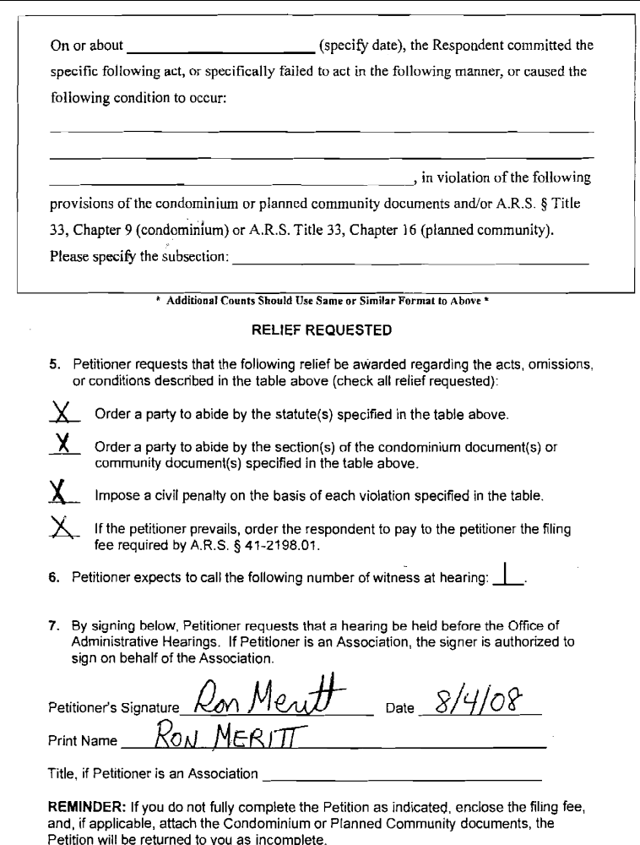

EXHIBIT 3. DECLARATION
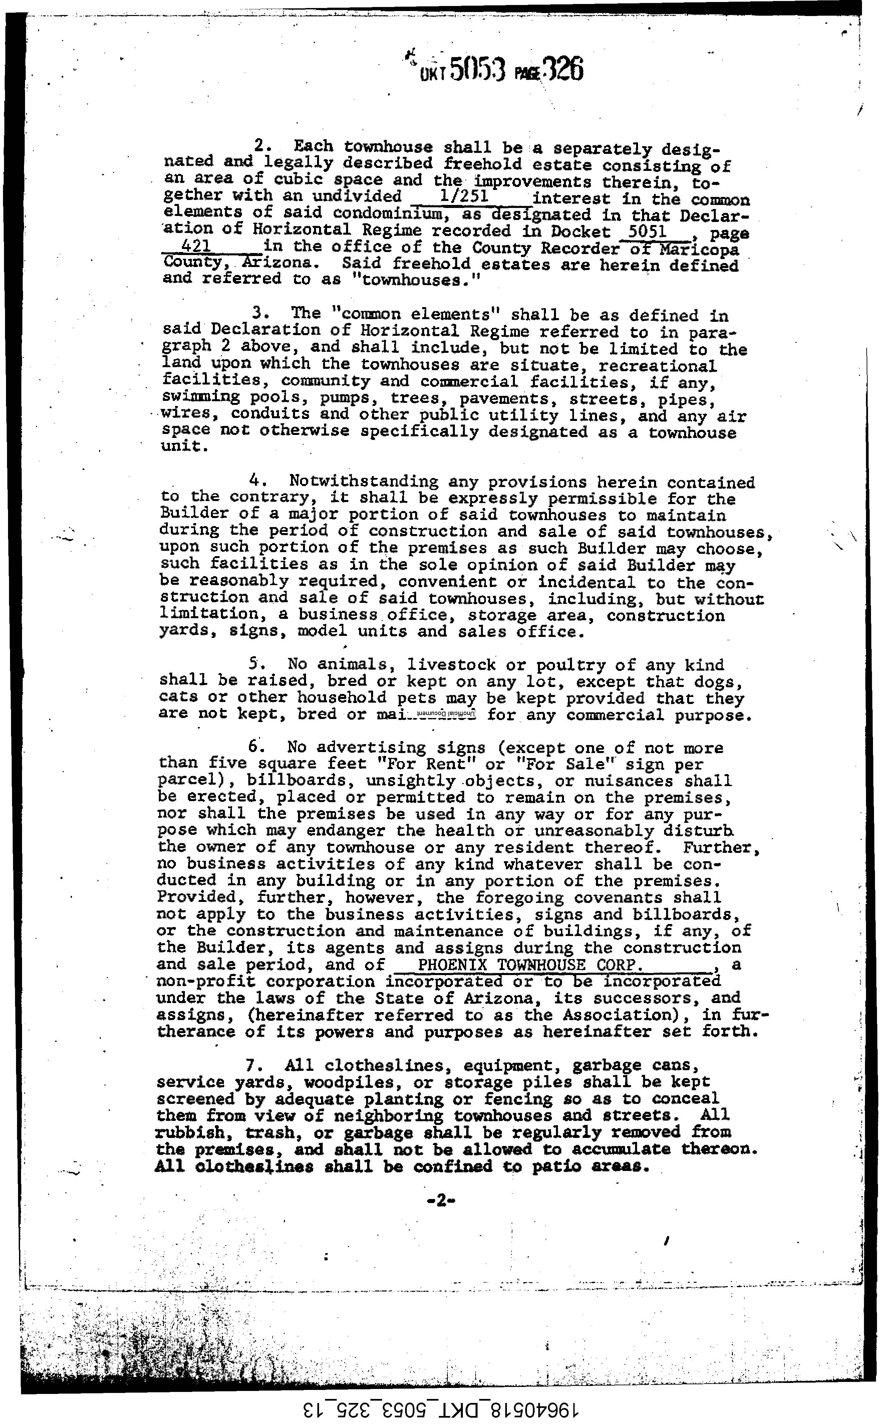

EXHIBIT 4. NOTICE FILING

